RAYA Phase 4 Blueprint

Persistent Farmer Intelligence Layer
The vision
- Today RAYA can make an excellent decision for a farmer.
- Phase 4 enables RAYA to make better decisions because it knows that farmer's history.
- Instead of answering isolated questions, RAYA begins maintaining a living agricultural memory.
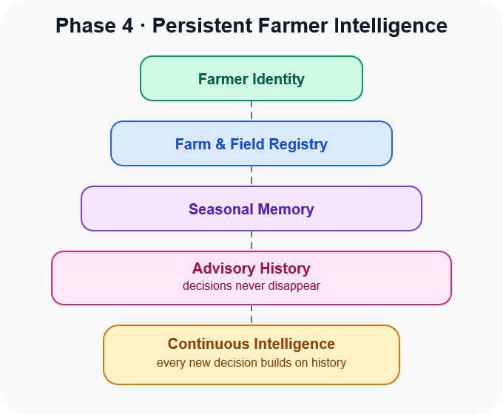
This is no longer a search engine. It's the beginning of an agricultural operating memory.

The four pillars
1. Identity — “Who am I helping?”
- Every farmer becomes a persistent individual.
- This isn't about names. It's about identity.
- A farmer owns farms. Farms contain fields. Fields contain soil. Soil carries long-term characteristics.
- That hierarchy becomes permanent.
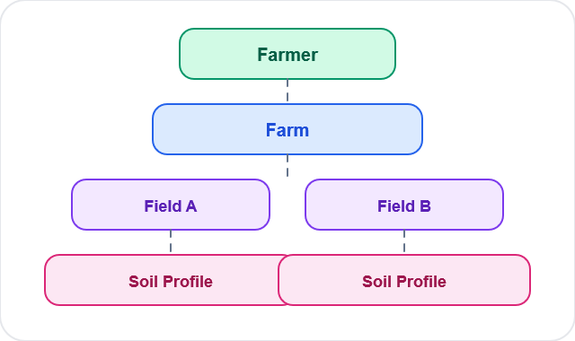
Notice that soil belongs to a field, not directly to the farmer. That mirrors reality.
2. Seasonal Memory — “What happened before?”
- Agriculture is cyclical.
- RAYA should remember seasons instead of isolated conversations.
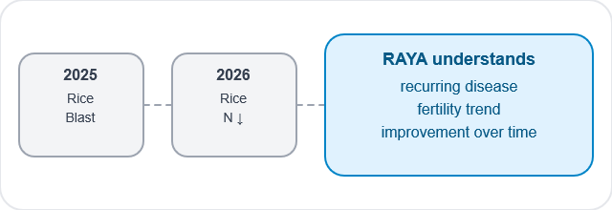
The goal is not storing dates. The goal is discovering patterns across years.

3. Advisory Memory — “Did my advice matter?”
This is the soul of Phase 4. Today RAYA gives recommendations.
Tomorrow it should remember them.
Example:
Date | Recommendation | Status
Aug 12 - | Improve drainage - | Completed
Aug 18 - | Apply nitrogen - | Pending
Aug 28 - | Monitor blast - | Completed

Now imagine the next conversation.
The farmer says: “How is my field?”
RAYA doesn't begin from zero. It replies:
“Last week I asked you to improve drainage. That was completed. The nitrogen application is still pending.”
That's companionship.

4. Living Farm Timeline
Instead of isolated reports, every field gains its own timeline.
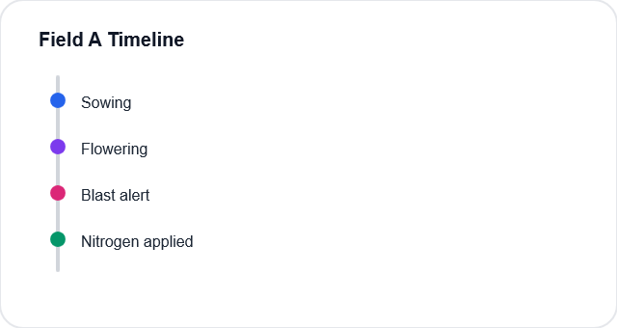
This becomes the farmer's agricultural diary. Not written manually. Generated automatically.

What changes for the farmer?
Today: "Tell me about my rice."
Phase 4: "Open Field 1."
That's a profound difference. The farmer no longer thinks in crops.
They think in their land. RAYA should think the same way.

What changes for RAYA?
Today RAYA observes states.
Phase 4 lets it observe transitions.
Instead of:
- Soil = deficient
It understands:
- Nitrogen improved compared to last season.
Instead of:
- Blast detected
It understands:
- This is the third consecutive flowering season with blast pressure.
That is the beginning of temporal intelligence.

Phase 4 Deliverables (Conceptual)
- Pillar 1 · Persistent Farmer Identity:
Farmers become permanent individuals with their own agricultural world.
- Pillar 2 · Farm & Field Registry;
Every farm, field, and soil profile becomes a long-lived asset.
- Pillar 3 · Seasonal Memory:
RAYA remembers previous crops, diseases, and soil evolution across seasons.
- Pillar 4 · Advisory History:
Every recommendation becomes part of a continuous decision journey.

Success criteria
We lock Phase 4 only when this sentence becomes true:
A farmer can leave today, return six months later, and RAYA continues the conversation from their farm's history without asking them to rebuild their world.
That is the conceptual blueprint. We still haven't touched databases, APIs, or implementation—because now we know what we're building before deciding how to build it.

